RETIREMENT OBJECTIVE:
Your goal is to retire and be financially independent when John is 65. Upon retirement, we have assumed monthly living expenses of $8,000 in today’s dollars. After adjusting for the effects of 3.00% inflation, however, you will actually need $12,838 per month.
In addition, we are also illustrating your family’s educational funding requirements first beginning in 2015. These costs are included in the total funding needs, since educational expenses often severely impact the amount of capital available at and for retirement.

RETIREMENT ASSUMPTIONS:
Monthly Retirement Income Desired at 65 $8,000
Present Working Capital $500,000
Additional Monthly Investments of $0
Annual Increase in Monthly Investments 3.00%
Current After-Tax Return on Working Capital 5.00%

We have assumed a beginning balance of $95,832 in your qualified retirement plans. By the time John is 65, these plans have grown to $576,160, due to your ongoing contributions and assumed rates of return. Based upon the methods we have chosen in withdrawing funds from each plan, the balance at life expectancy is $508,826.

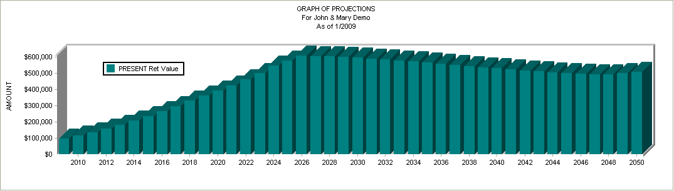

RETIREMENT FINDINGS:
We calculate that, given these assumptions, your present efforts will prove inadequate to meet your retirement needs. To alleviate this problem you have several choices:
1. Retire later
2. Reduce your retirement income goal
3. Seek higher returns
4. Invest more money periodically
5. Lower your tax bracket
6. Some combination of the above

For example, if you were to continue to save and invest in the same general manner as the present where you are earning approximately 5.00% after tax, you will need to increase your investment contributions to $4,114 per month.
Another alternative would be to increase the after-tax rate of return on both your present working capital and your monthly investments to 8.24%. Either of these alternatives could fund your present retirement income shortage
.
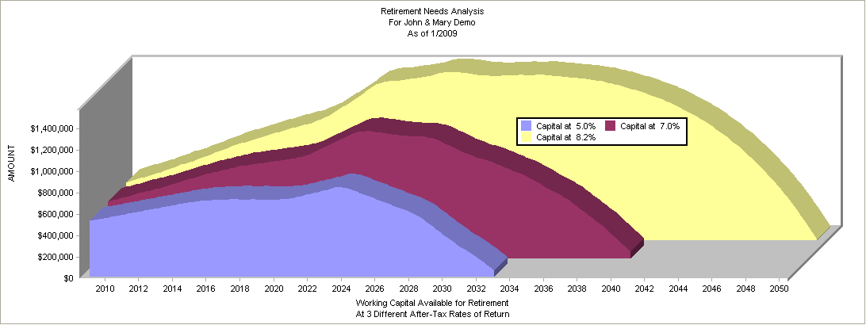

CONCLUSION:
Based on our calculations, assuming $500,000 in present resources and additional monthly investments of $0, you will need to achieve an after-tax rate of return of 8.24% in order to meet your retirement income objective. Among the most common investments used to achieve this rate of return are:
Growth/Income Mutual Fund
High Quality Common Stocks
Moderately Leveraged Real Estate
Variable Annuities
Real Estate Investment Trusts

